PickMe’s operations are primarily in the Passenger Ground Transport Industry (PGT) (70%) and diversified into Technology and Logistics (30%)

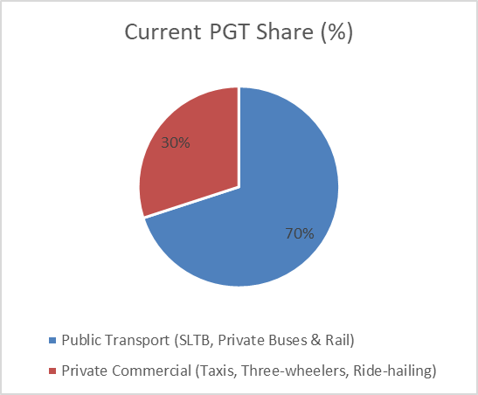
The prominent role played by the government

Public transport currently dominates the PGT industry with a 70% market share. But more than 50% of the fleet has passed its economic life with negative or little growth in the fleet. Passenger public transport trips have declined in recent years; for example, bus usage dropped sharply from 34.6% in 2019 to 16.6% in 2021, and is likely to continue decreasing as the government limits subsidies on transport modernization due to high public debt, making it reliant on private and foreign investment via PPPs. However, the government has approved the development of multimodal transport hubs to improve public transport efficiency and connectivity between buses, trains, and rental vehicles. The lifting of the vehicle import ban in July 2025 led to a drastic increase in new vehicle registrations (motorcycles- 75%, motor cars- 15%, three-wheelers- 2.5%, dual-purpose vehicles- 1.5%) despite the double increase in excise duties, customs import duty (CID), luxury tax, and VAT imposed. While the government promotes EVs, lost fuel-tax revenue led to higher import tax rates. Despite new registrations, private vehicle ownership remains largely unaffordable, and demand for affordable transport is high. Existing public transport capacity is insufficient, making investments in public transportation justifiable and opening doors for alternative, affordable transport entrants.

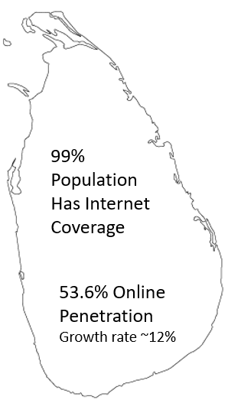
Digital penetration led to new entrants and the rise of the gig economy

Digitalization, Urbanization, and Internet penetration have enabled non-commercial motive personal vehicles to enter the industry via ride-hailing platforms, expanding the PGT industry. Sri Lanka’s telecommunications networks currently cover around 91% of the country’s land area and reach approximately 99% of the population. Sri Lankan online penetration stood at 53.6% (of which 92% possess smartphones). However, 46% of the population remains offline, primarily due to high internet costs, limited device access, and low connection speeds. Despite these challenges, internet penetration in Sri Lanka is rising rapidly, with a 7% increase from January 2024 to January 2025 and a 12% growth from October 2024 to October 2025.
Currently, ride-hailing has penetrated less than 6% of internet users. dominated by a duopoly (PickMe -70%, Uber -25%, Others -5%) with an expected annual growth rate of 8.89% between 2025 and 2030, with 5.54m users. The total addressable market is estimated at over 1.1 billion private vehicle trips annually, compared to around 2.16 billion public transport trips. Less than 6% of three-wheelers in Sri Lanka use ride-hailing platforms, indicating that the country’s mobility and digital logistics market remains largely underpenetrated. E-commerce user penetration is expected to hit 14.1% by 2029.
Urbanization is leading to higher demand for ride-hailing as a convenient transport option. Private vehicles entering the industry is developing a gig economy that is flexible for drivers who often depend on these platforms for income. However, ride-hailing services are not yet regulated by the government.

